Grades: What do they tell us about ourselves and our students?

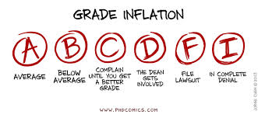

Country | Pass | Acceptable/Average | Exemplary
Australia | 50 | 63 | 83
Belgium | 60 | 70 | 90
Canada | 50 | 60 | 80
Finland | 40 | 54 | 86
Germany | 50 | 62 | 92
Ireland | 47 | 53 | 73
Singapore | 50 | 60 | 80
Taiwan | 50 | 60 | 70
UK | 40 | 50 | 70
Florida | 60 | 70 | 90
AP Calculus | 39 | 39 | 68
MLB-Batting Avg | 20 | 25 | 30

http://www.rug.nl/feb/education/exchange/courseinformation/gradeconversionfeb.pdf
http://www.leg.state.fl.us/Statutes/index.cfm?App_mode=Display_Statute&URL=1000-1099/1008/1008.html
http://apcentral.collegeboard.com/apc/public/repository/calculus-released-exam-2008-scoring-worksheet.pdf
http://www.ask.com/sports-active-lifestyle/good-batting-average-baseball-59521ab10570c194
http://www.phdcomics.com/comics/archive.php?comicid=1675
http://www.wisdomenough.com/the-lower-half-club/

