Research Project

Assignment

The purpose of this assignment is to expose students to actual research, without the formalities of an Institutional Review Board, and allow them to demonstrate their mastery of the research process and the statistical principles learned in this course. Students will pick a research question, develop a proposal (see attached), implement the proposed research, analyze and interpret data, and create a five minute presentation on the findings.

Directions

Using Rivermail, send me an email (cclark@irsc.edu) with “Islands Email” in the subject line. In the body type your name (First Last) and a private email account (filters won’t allow for Rivermail account). For example, Carl Clark smartdonkeyhole@gmail.com.

When you receive a response to above, go to http://islands.smp.uq.edu.au/login.php and click on “Need to set or reset your password?” and follow the directions.
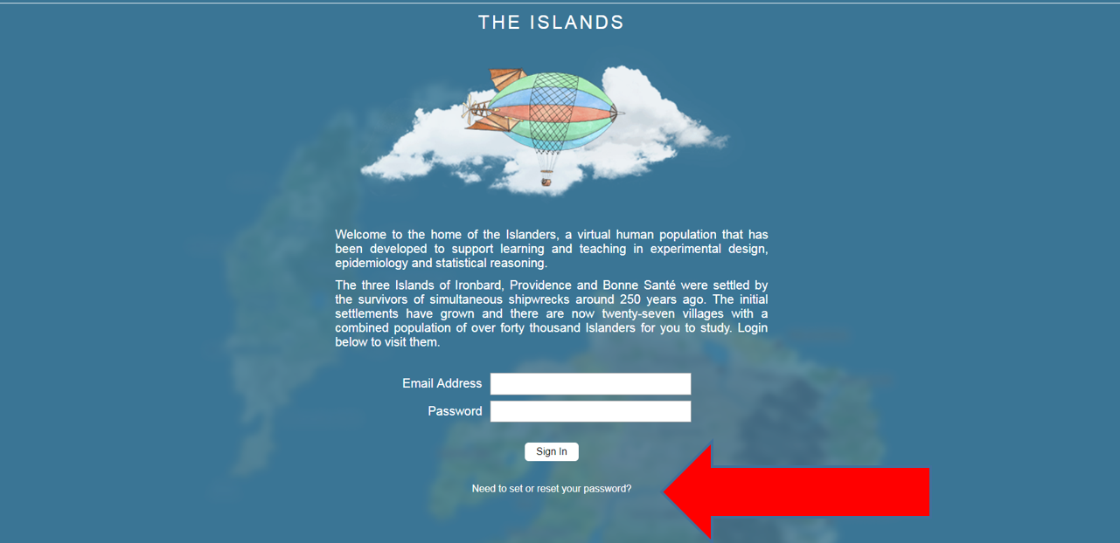

Orientate yourself to the Islands by clicking on the Visitor Center (located on the big island’s right side) and then visit cities, schools, halls, etcetera (save the houses for last). Click on a house and find one adult who will grant consent (House/Name/Tasks/”Obtain consent from …”); this may take several tries. Do NOT complete “experiments” on multiple people.
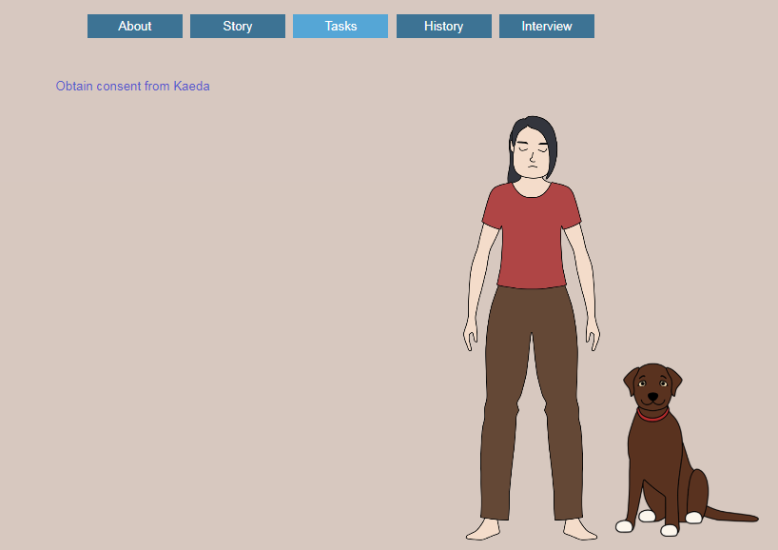

Once you have a participating adult, examine the numerous possibilities that exist for answering possible research questions (e.g., Does chewing cocoa leaves affect short term memory?), and develop a research question.

Using Rivermail, email me your research question.

Once you receive approval of your research question, then you may complete your proposal (see attached).

Submit your proposal via Blackboard. When you receive approval, you may begin collecting data.
Presentation & Artifact

After completing the research, create a slide presentation (e.g., PowerPoint) that will be delivered in class and create an artifact to upload into Blackboard. The presentation will last five minutes, both the artifact and the in-class version. It must be well polished and not rely on written text.

You must have a slide for the topic (i.e., research question), the literature review, hypotheses, design of the experiment, results, limitations & recommendations, and references. Slides should NOT be covered in words!

There are several options for creating an artifact:

- Animated PowerPoint https://support.office.com/en-us/article/record-a-slide-show-with-narration-and-slide-timings-0b9502c6-5f6c-40ae-b1e7-e47d8741161c

- Video record yourself and a projection; see Dr. Mallonee or myself about borrowing equipment.

- Screen capture https://www.google.com/search?q=record+screen&oq=record+scr&aqs=chrome.0.0j69i57j0l4.6128j0j4&sourceid=chrome&ie=UTF-8

General Scoring Guide

Exemplary Response ER (full credit) – Gives a complete response with a clear, coherent, unambiguous, and eloquent explanation. The response is accurate, complete, and fulfills all the requirements. Necessary supporting information or examples are included.
Competent Response CR (four-fifths credit) – Gives a fairly complete response with reasonably clear explanations. The response is accurate and fulfills the requirements, but supporting information or examples are either incomplete or lacking.
Satisfactory Response SR (three-fifths credit) – The response includes information that is basically correct, but the information is too general or simplistic. The explanation also might be muddled, and supporting information or examples might be incomplete or omitted.
Inadequate Response IR (zero to two-fifths credit) – The response indicates a very limited understanding of the concept. It is incomplete, inaccurate, irrelevant, or not understandable.

